List of the Function those are using in sheet

1. Quick Statistics
2. Conditional formatting
3. Sum and Sumif
4. Unique function
5. Filter function
6. Vlookup (Xlookup)
7. Index match function
8. IF and IFS
9. Pivot table

**QUICK STATISTICS :-** in this function we get statistical information about data we use some function AVERAGE ,MEDIAN ,RANGE MAX, MIN, function

**USE**:- By use these function we get the main information about data by these we get summarization and Visualization about data

Advantage

* give quick review about data
* Time saving
* Fast Summarization and visualization

Disadvantage

* Not able to show minor information

Eg.

|  |  |  |  |  |  |
| --- | --- | --- | --- | --- | --- |
| **Column1** | **Column2** | **Column3** | **Column4** | **Column5** | **Column6** |
| **Geography** | **Amount** | **Units** |  | Average | $ 20,791.17 |
| India | $ 24,353.00 | 627.00 |  | range | $ 19,698.00 |
| Canada | $ 26,257.00 | 534.00 |  | Min | $ 10,514.00 |
| UK | $ 13,349.00 | 1,206.00 |  | Max | $ 30,212.00 |
| USA | $ 30,212.00 | 1,929.00 |  | Median | $ 22,207.50 |
| New Zealand | $ 20,062.00 | 561.00 |  |  |  |
| Australia | $ 10,514.00 | 624.00 |  |  |  |

**EXPLORATORY DATA ANALYSIS:-** these function show the

Visual Representation of the data it show representation of data in the form of bar , highlight, scales representation of data

**USE** :- show data easy to visualize data

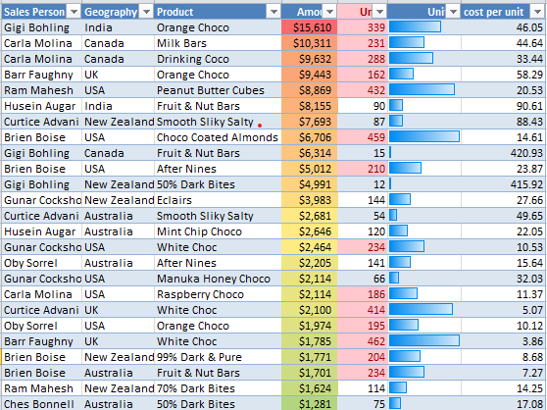

**SUM & SUMIF FUNCTION:-** this function adds up all the numbers in a range of cell

Add up all number in a range with some limits

IF FUNCTION:- it was a function that check condition of the given data is true and false

**USE :-** this function mainly use for the total of the any range and subtotal

eg

|  |  |  |
| --- | --- | --- |
| **Geography** | **Amount** | **Units** |
| India | $ 24,353.00 | 627.00 |
| Canada | $ 26,257.00 | 534.00 |
| UK | $ 13,349.00 | 1,206.00 |
| USA | $ 30,212.00 | 1,929.00 |
| New Zealand | $ 20,062.00 | 561.00 |
| Australia | $ 10,514.00 | 624.00 |
|  | **$ 1,24,747.00** | **5,481.00** |

In this table I am using sum function for the given table so we use SUM function to get the total value of the some given range for total I am use

=SUM(J9:J14) it is given total $ 1,24,747.00

When we are using SUMIF function so we get the data in certain limit

we want total amount it is SUM but only for India is CERTAIN use by SUMIF

we want total amount by different country

=SUMIFS(Sheet1!D2:D30, Sheet1!B2:B30, "India")

It will given value given in table

WHERE USE:- it is mainly use in Financial calculation or for some specific values

ADVANTAGE

SUM:- Simple and straightforward way to add up numbers quickly.

SUMIF:- Enables summing based on specific criteria, enhancing data analysis capabilities.

DISADVANTAGE

SUM:- Limited functionality compared to more advanced aggregate functions.

SUMIF:- May not be suitable for complex conditions or multi-criteria summing.

**INDEX-MATCH:-** In this function there two function combine and perform there task.

It will also perform lookup in combine form search for a value in specific row or column and get that value from corresponding row or column after matching criteria.

**WHY USE :-** It was alternative of look formula it will working on large data set when the lookup value is not in the first column of the table Array.

**WHERE TO USE:-**It will working on 2-D lookup and the lookup value is not in first column of the array.

**ADVANTAGE:-** Offers more flexibility and efficiency than VLOOKUP, with large datasets.

**DISADVANTAGE**:- Requires knowledge of two separate functions and their syntax

EXAMPLE:-

|  |  |  |  |  |
| --- | --- | --- | --- | --- |
| **Name** | **Gender** | **Department** | **Date Joined** | **Salary** |
| Barr Faughny | Female | Procurement | 06-Oct-19 | $75,000 |
| Dennison Crosswaite | Male | Website | 16-May-19 | $90,700 |
| Gunar Cockshoot | Male | Website | 11-Jan-19 | $48,950 |
| Gigi Bohling | Male | Sales | 08-Sep-18 | $74,550 |
| Curtice Advani | Male | Finance | 05-Apr-19 | $59,810 |
| Kaine Padly | Male | Website | 20-Nov-18 | $1,07,700 |
| Ches Bonnell | Male | Website | 22-Jul-18 | $88,050 |
| Andria Kimpton | Male | Website | 18-May-18 | $69,120 |
| Brien Boise | Female | Website | 12-Jun-19 | $58,100 |
| Husein Augar | Female | Finance | 12-Sep-18 | $67,910 |
| Jan Morforth | Male | Finance | 29-Sep-17 | $48,170 |
| Dotty Strutley | Female | Website | 10-Jan-18 | $41,980 |
| Marney O'Breen | Female | Finance | 01-Jul-18 | $65,920 |
| Rafaelita Blaksland | Female | Sales | 30-Aug-18 | $1,09,160 |
| Beverie Moffet | Female | Finance | 20-Feb-18 | $75,970 |
| Oby Sorrel | Female | Finance | 02-Jun-19 | $58,940 |

**Other data**

|  |  |  |
| --- | --- | --- |
| **Department** | **Gender** | **Bonus %** |
| Finance | Female | 4% |
| Procurement | Female | 5% |
| Sales | Female | 3% |
| Website | Female | 6% |
| Finance | Male | 3% |
| Procurement | Male | 4% |
| Sales | Male | 4% |
| Website | Male | 5% |

**Q.1 If we want to know which employee joined on 20-Nov-18**

First I am use match function that given position of the data in the row by function =MATCH(B23,D2:D17,0) B23 shoow what we want to search , Range of that data ,last match type ans given is 6 position of the match

Then use Index function to get other information about that match like we want name of the employee =INDEX(A2:A17,MATCH(B23,D2:D17,0)) A2:A17 show range that data and position of that row showen by match function

Name is Kaine Padly

Q.2 **Which employee has Salary 88000 ?**

=INDEX(A2:A17,MATCH(B30,E2:E17,1)) use this function and get Marney O'Breen

**VLOOKUP (XLOOKUP):-** This function use for search for the value in data( xlookup is more update version of vlookup function with more capable use in large data set )

**USE:-** use for searchfirst column of the table Array and given value in the same row from another column.

applications for tasks like retrieving product information, customer data, or financial records from large datasets.

**ADVANTAGE:-** Use in simple lookup task

**DISADVANTAGE:-** Make errorin large data or incomplete data limited capable in vertical data

EXAMPLE:-

|  |  |  |  |
| --- | --- | --- | --- |
| **Sales Person** | **No. Customers** | **Net Sales** | **Profit** |
| Joseph | 8 | $1,592 | $563 |
| John | 8 | $1,088 | $397 |
| Josh | 8 | $1,680 | $753 |
| Jamie | 9 | $2,133 | $923 |
| Jackie | 10 | $1,610 | $579 |
| Johnson | 10 | $1,540 | $570 |
| Jonathan | 7 | $1,316 | $428 |
| Jagjit | 7 | $1,799 | $709 |
| Jairam | 8 | $1,624 | $621 |
| Jessy | 6 | $726 | $236 |
| Javed | 9 | $2,277 | $966 |
| Jimmy | 6 | $714 | $221 |
| Juno | 9 | $2,682 | $1,023 |

Q.1 What is the sales of Jagit ?

Use function =VLOOKUP(A9,$A$2:$D$14,3,FALSE) Use for the information about we want about ,Fix range of the data use by ,$A$2:$D$14 and we want the value from which column use 3 for get data about salary

Answer 1799

Q2. What is All data of Javed ?

Use function for get data about javed =VLOOKUP(G9,$A$2:$D$14,{1,2,3,4},FALSE) if we want all column data then we just use the no. of the column in array table 1,2,3,4 we will use in it

**IF FUNCTION :-** It logical function that test value and get one value if condition is true and another value if the condition is false.

**USE :-** It make decision based on condition use it to categorize data various scenarios such as financial modelling

**ADVANTAGE:-** Provides flexibility in decision-making based on conditions.

**DISADVANTAGE:-** Can become complex and difficult to manage in multiple IF statements.

|  |  |  |  |  |
| --- | --- | --- | --- | --- |
| **Name** | **Gender** | **Department** | **Date Joined** | **Salary** |
| Barr Faughny | Female | Procurement | 06-Oct-19 | $75,000 |
| Dennison Crosswaite | Male | Website | 16-May-19 | $90,700 |
| Gunar Cockshoot | Male | Website | 11-Jan-19 | $48,950 |
| Gigi Bohling | Male | Sales | 08-Sep-18 | $74,550 |
| Curtice Advani | Male | Finance | 05-Apr-19 | $59,810 |
| Kaine Padly | Male | Website | 20-Nov-18 | $1,07,700 |
| Ches Bonnell | Male | Website | 22-Jul-18 | $88,050 |
| Andria Kimpton | Male | Website | 18-May-18 | $69,120 |
| Brien Boise | Female | Website | 12-Jun-19 | $58,100 |
| Husein Augar | Female | Finance | 12-Sep-18 | $67,910 |
| Jan Morforth | Male | Finance | 29-Sep-17 | $48,170 |
| Dotty Strutley | Female | Website | 10-Jan-18 | $41,980 |
| Marney O'Breen | Female | Finance | 01-Jul-18 | $65,920 |
| Rafaelita Blaksland | Female | Sales | 30-Aug-18 | $1,09,160 |
| Beverie Moffet | Female | Finance | 20-Feb-18 | $75,970 |
| Oby Sorrel | Female | Finance | 02-Jun-19 | $58,940 |

**Q.1** Either female or Sales department

Use =IF(OR(B7="Female",C7="Sales"),"INCLUSION","EXCLUSION") to solve this condition after if function we use logic(AND,OR) to apply on it and the function shows that if female then inclusion if not then goes to sales condition true then show exclusion

Q.2 who join on department Finance or year 2019 and salary <90,700 Exclusion and inclusion

Use this function to solve this =IF((C7="Sales")+(YEAR(D7)=2019)>=2,$K$1,$K$2)

Q3. Joined Between jan2018 tp jan 2019

To solve this question

=IF(AND(D7>=DATE(2018,1,1),D7<=DATE(2019,1,1)),"YES","NO")

|  |  |  |  |  |
| --- | --- | --- | --- | --- |
| **Q1** |  | **Q2** |  | **Q3** |
| INCLUSION |  | EXCLUSION |  |  |
| EXCLUSION |  | INCLUSION |  | NO |
| EXCLUSION |  | INCLUSION |  | NO |
| INCLUSION |  | INCLUSION |  | YES |
| EXCLUSION |  | INCLUSION |  | NO |
| EXCLUSION |  | INCLUSION |  | YES |
| EXCLUSION |  | EXCLUSION |  | YES |
| EXCLUSION |  | INCLUSION |  | YES |
| INCLUSION |  | INCLUSION |  | NO |
| INCLUSION |  | INCLUSION |  | YES |
| EXCLUSION |  | INCLUSION |  | NO |
| INCLUSION |  | INCLUSION |  | YES |
| INCLUSION |  | INCLUSION |  | YES |
| INCLUSION |  | INCLUSION |  | YES |
| INCLUSION |  | EXCLUSION |  | YES |
| INCLUSION |  | INCLUSION |  | NO |

**PIVOT TABLE:-** Table thatshow summarization of data without using formulas in sheet

**USE:-** use in dataanalysis and report purpose we can summarized large data

**ADVANTAGE :-** time efficient it does not take more time then other

Less complex to use

**DISADVANTAGE :-** required to learnmore thing for fully utilize it

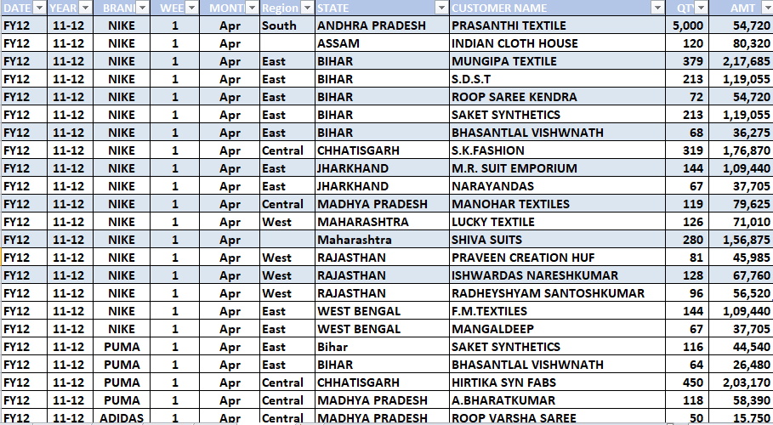

I am use this data set in it

Q.1 Make Month wise data of Brand

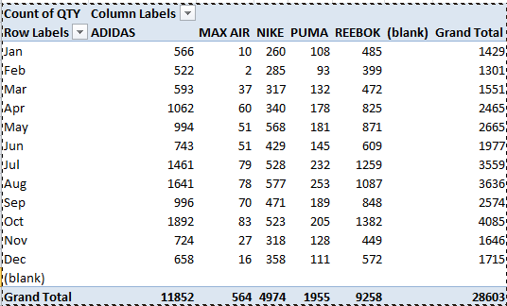

Q2. Make analysis of al brand with there quantity

|  |  |  |
| --- | --- | --- |
| **Row Labels** | **Sum of QTY** | **Sum of AMT** |
| ADIDAS | 887658 | 475400006 |
| MAX AIR | 130052 | 48404887 |
| NIKE | 1116750.75 | 595447111 |
| PUMA | 366053 | 194805872 |
| REEBOK | 759065 | 401470894 |
| (blank) |  |  |
| **Grand Total** | **3259578.75** | **1715528770** |

­Q.3 Make connect report connection by slicer with two pivot table

First table

|  |  |  |  |  |  |  |  |
| --- | --- | --- | --- | --- | --- | --- | --- |
| **Sum of QTY** | **Column Labels** |  |  |  |  |  |  |
| **Row Labels** | **Central** | **East** | **North** | **South** | **West** | **(blank)** | **Grand Total** |
| ADIDAS | 107807 | 201607 | 6406 | 234027 | 299935 | 37876 | 887658 |
| NIKE | 89507 | 654324 | 28648 | 98723 | 222709.75 | 22839 | 1116750.75 |
| **Grand Total** | **197314** | **855931** | **35054** | **332750** | **522644.75** | **60715** | **2004408.75** |

Second table

|  |  |
| --- | --- |
| **Row Labels** | **Sum of AMT** |
| ADIDAS | 475400006 |
| NIKE | 595447111 |
| **Grand Total** | **1070847117** |

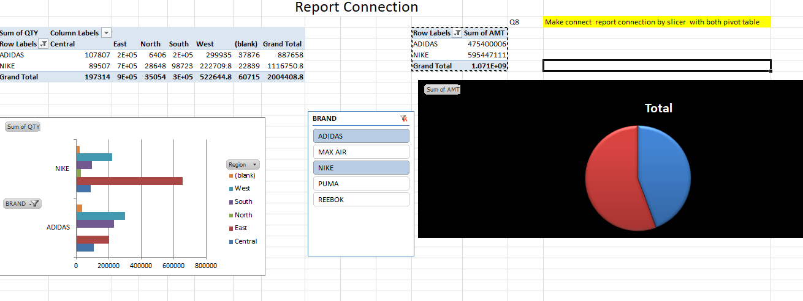

In this sheet I am use slicer to get an specific data and connect one slicer with two different table

Due to this we get different dynamics of the data by slicer